Copyright for test papers and marking guides remains with West Australian Test Papers.
Test papers may only be reproduced within the purchasing school according to the advertised Conditions of Sale.
Test papers should be withdrawn after use and stored securely in the school until Wednesday 11th October 2017.


MATHEMATICS
METHODS
UNITS 3 & 4

Semester Two

2017

SOLUTIONS

Calculator−free Solutions

1. (a) 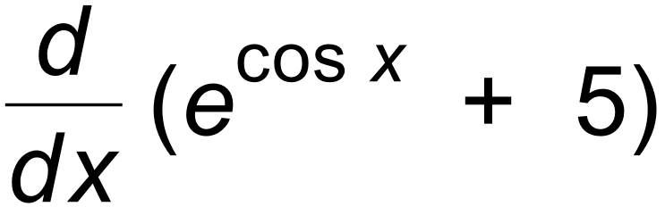
= – sin x e ^{cos x}
(b) 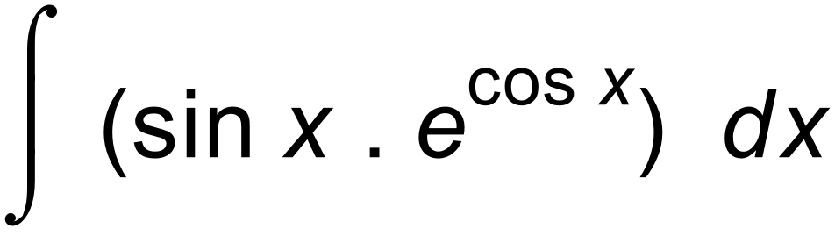
= 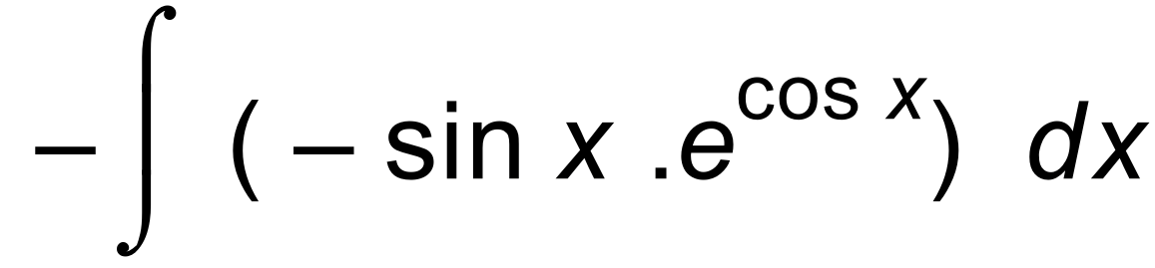
= – e ^{cosx} + c [4]

2. (a) f ´(x) = 2e^{2x} – 
For max/min, 2e^{2x} –  = 0
 2xe^{2x} – 1 = 0
x = 0.5 e ^{–2x}
(b) f ′′(x) = 4e^{2x} + 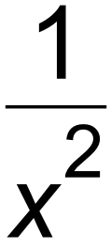
Since expression > 0 for all x values,
then stationary point is a minimum. [5]

3. (a) A = 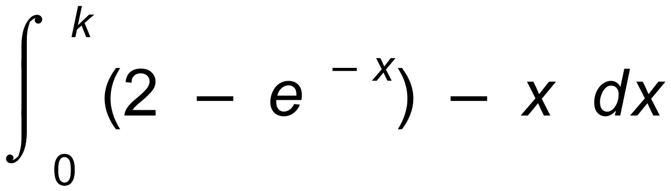
(b) A = 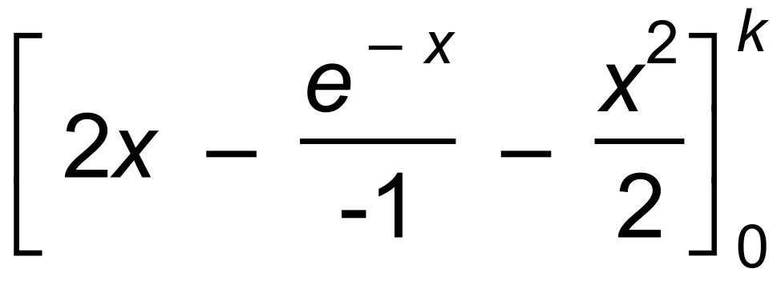
= (2k + e ^{–k} – 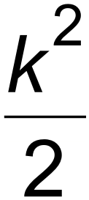 ) – 1 [5]

4. (a) 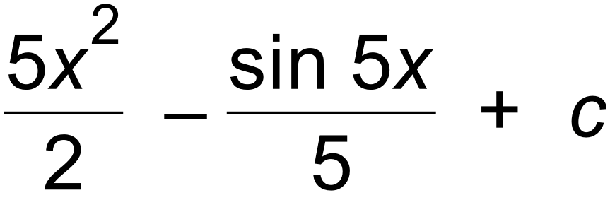
(b) 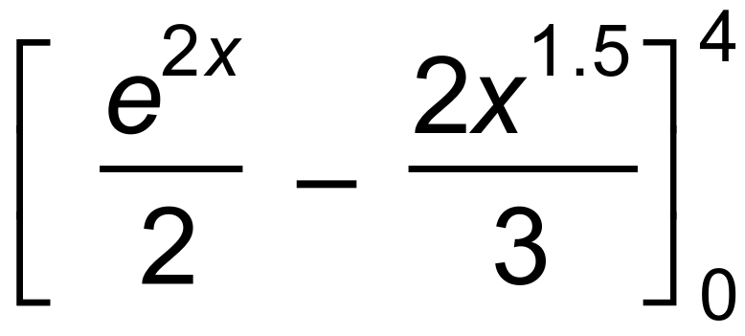
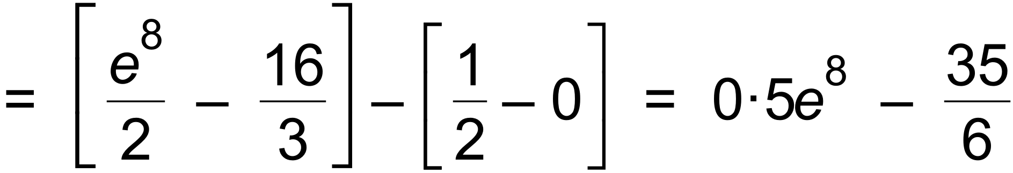
(c) 2 sin 2x [7]

5. (a) x = sin 2t + e ^{–2t} +c
x(0) = 0+1 + c = 1  c = 0
x = sin 2t + e ^{–2t}
(b) a = –4sin 2t + 4e ^{–2t}
(c) Assume a = – k²x
Then –4 sin 2t + 4 e ^{–2t} = – k²(sin 2t + e ^{–2t})
This leads to the result that k² = 4 and k² = –4.
Hence, relationship is false.
Or a = –4(sin 2t – 4e ^{–2t}) 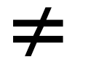−4(sin 2t + 4e ^{–2t}) = −2²x
[7]

6. (a) log ( 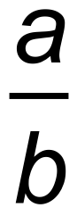 ) + log ( 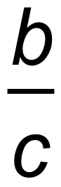 ) + log ( 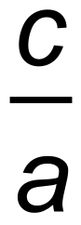 )
= log 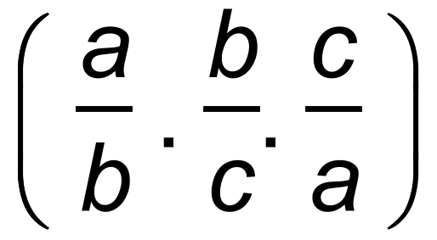
= log 1 = 0
(b) y = 1 – x
2^{x} = 3^{1 – x}
x log 2 = (1 – x)log 3
x log 2 + x log 3 = log 3
x = 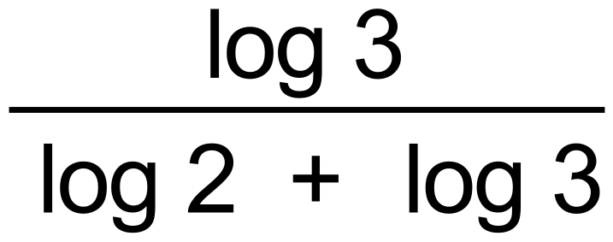
x = 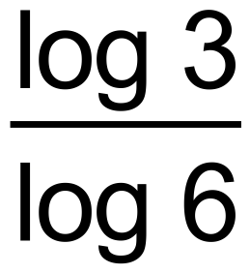 as required
y = 1 –  [7]

7. (a) (i) 14
(ii) 14 + 6 – 6 = 14
(iii) 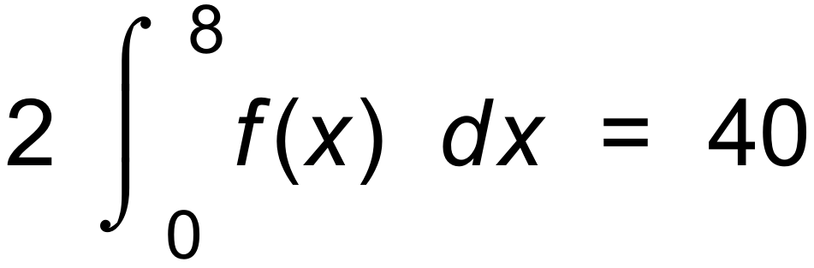
(b) 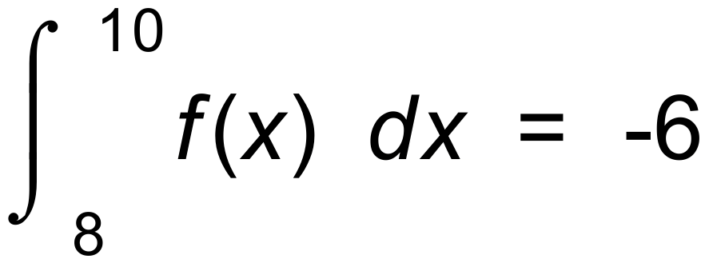
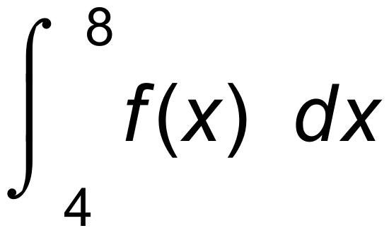 = 6
 a = 4, b = 8, c = 10 [8]

8. (a) A = Length x Width = 3xcos 2x
(b) A = 3x cos 2x
A′ = 3x (–sin 2x)(2) + 3cos 2x = 0 for max / min
6xsin 2x = 3cos 2x
2x tan 2x = 1 as required.
(c) A′′ = –12 sin 2x – 12xcos 2x
= –12(sin 2x + xcos 2x)
< 0 for maximum
 sin 2x + x cos 2x > 0 as required [7]

Calculator−assumed Solutions

9. (a) Solve 0.9 = 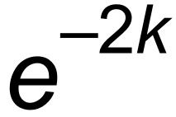
∴ k = 0.05268 = 0.0527 ( 3 s.f.)
(b) Solve 0.5 = 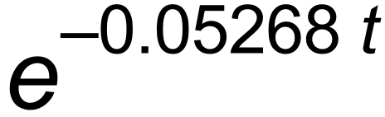
t = 13.153
Half life is 13.153 years.
(c) 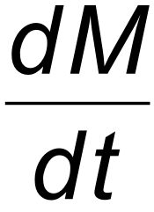 = M₀ e ^{–k t} . (–k)
At t = 2,  = 20 . e ^{– 0.0527 (2}) . (–0.0527)
= – 0.9486 units of mass per year. [7]

10. (a) Only 2 results for each trial–single or married.
(b) 0.6
(c) 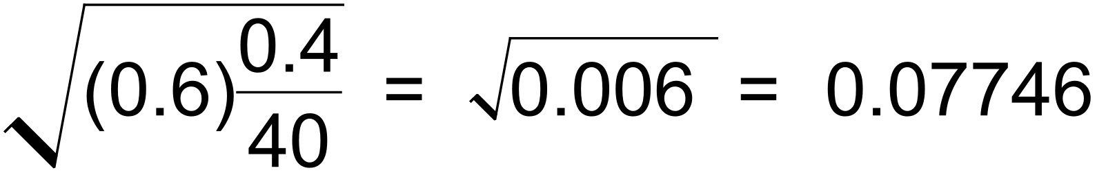
(d) We can be 95% confident that the true proportion is p
where 0.6 –(1.96)( 0.07746) < p < 0.6 + (1.96)( 0.07746)
ie 0.4482 < p < 0.7518
(e) n = 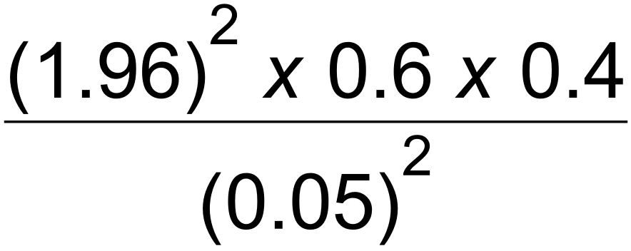
n = 368.8
Sample size needs to be 369. [9]

11. (a) From calculator, 0.142
(b) sin x has a minimum of –1. So, 2 + sin x has a minimum of 1
So log(2 + sin x)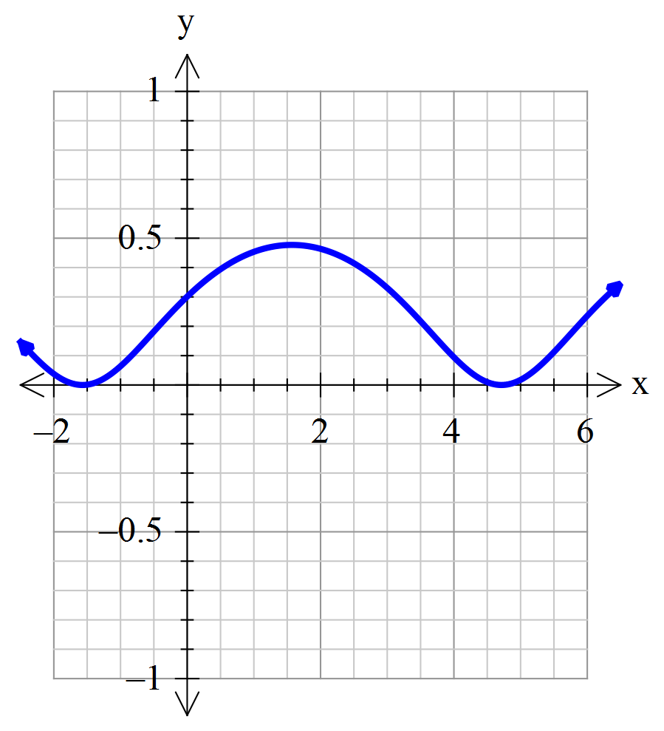 has a minimum of 0.
(c)

(d) By inspecting the graph, all of this curve is above the x axis.
 since 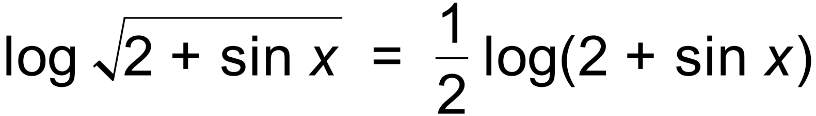
Area = 0.5(0.142) = 0.071 [9]

12. (a) Minimum when f ′(x) = 0
∴ 2 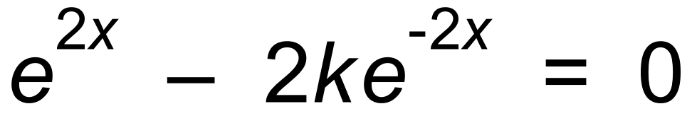
∴ 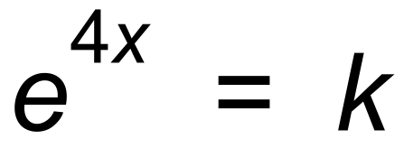
∴ x = 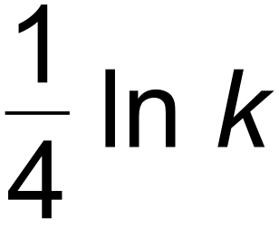
∴ Minimum value is 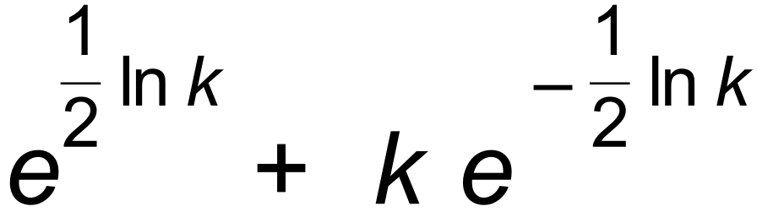
= 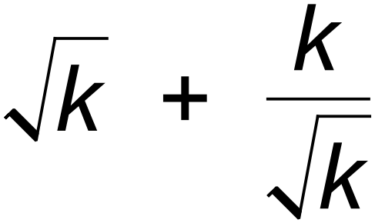 = 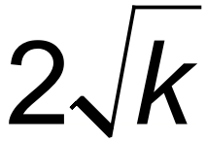
∴ Range is 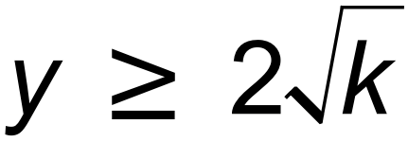
(b) 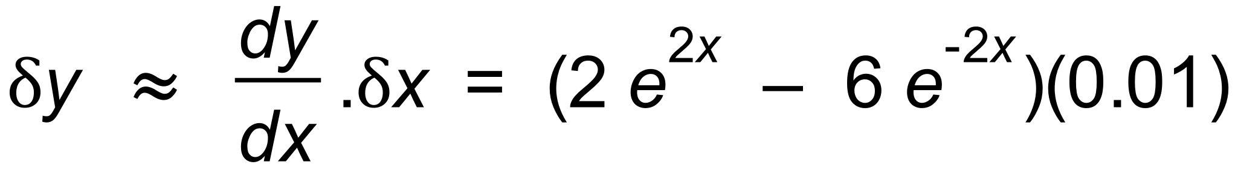
= 1.09 ( 2 decimal places)
(c) f(2) = 54.653
f(2.01) = 55.755
Change is 1.10 ( 2 decimal places) [9]

13. (a) Not equally likely outcomes, so biased.
(b) 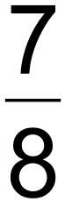
(c) E(X) = 1.875 Var(X) = 1.0533² = 1.109
(d) P(Y = 4) = ⁵C₄ (0.25)⁴(0.75) = 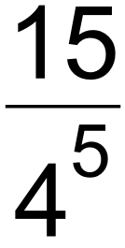 = 0.0146
(e) P(five 4s) = 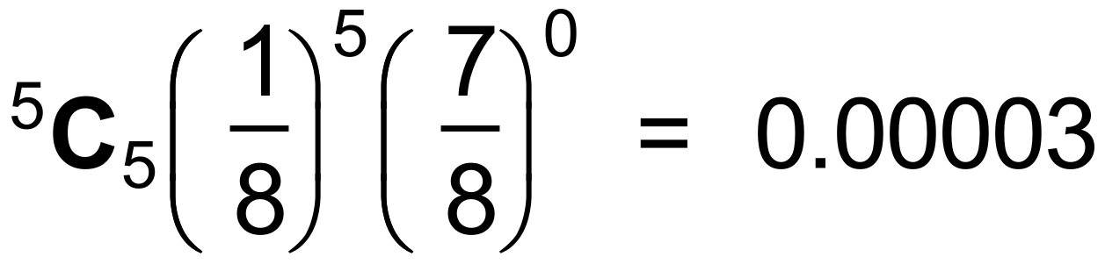
[8]

14. (a)

z | 1.1 | 1.3 | 1.7 | 2.0 | 2.4
d | 130 | 220 | 490 | 800 | 1400
Log z | 0.0414 | 0.1139 | 0.2305 | 0.3010 | 0.3802
Log d | 2.11 | 2.34 | 2.69 | 2.90 | 3.15

(b)
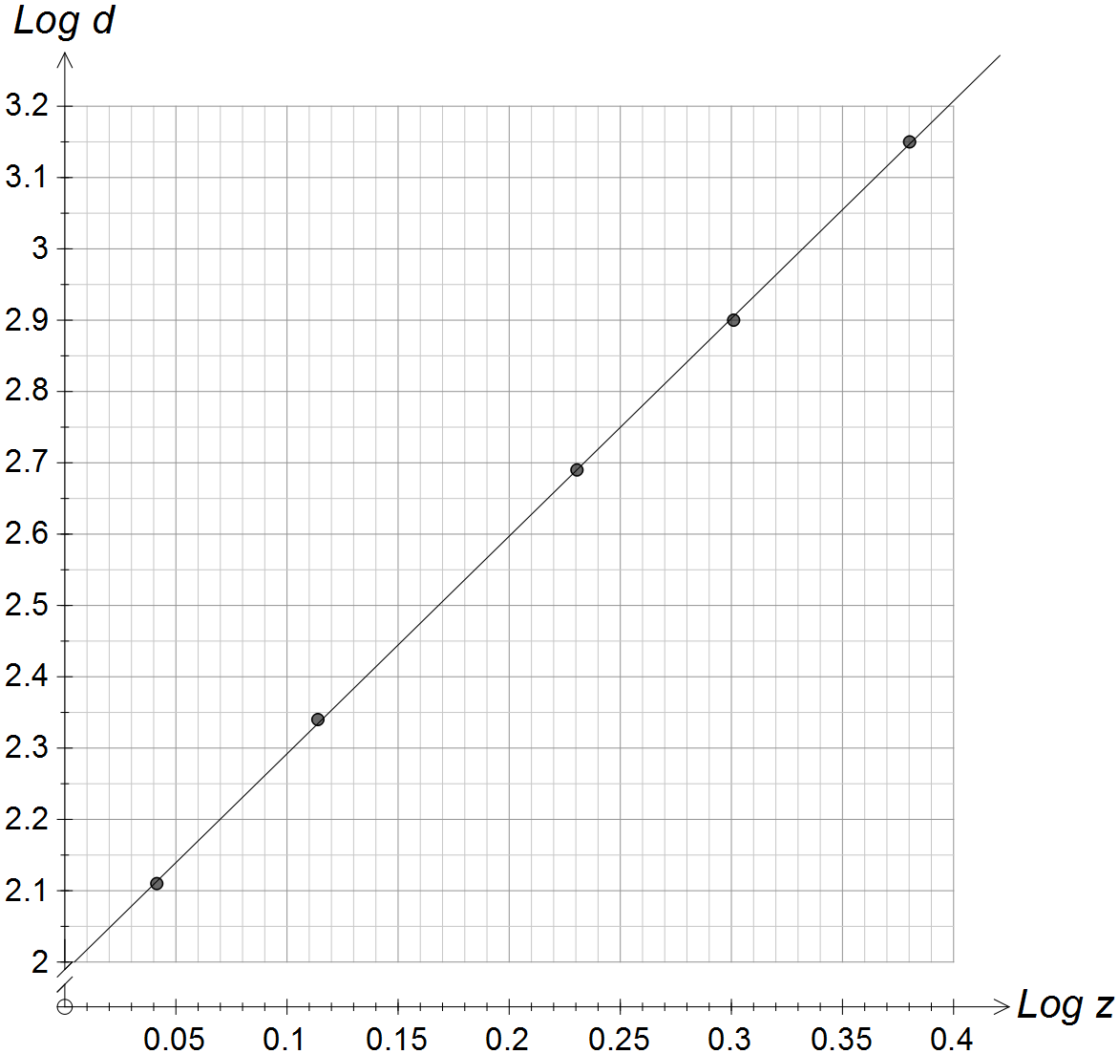

(c) log d = 2 + 3log z
(d) d = 100.z³ [9]

15. (a) A = 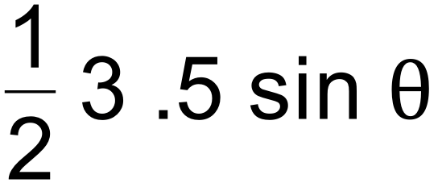 = 7.5 sin 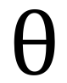
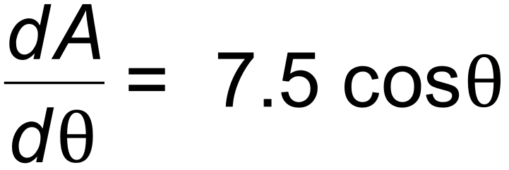
(b) 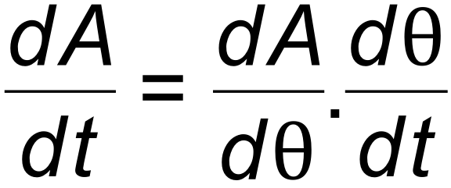
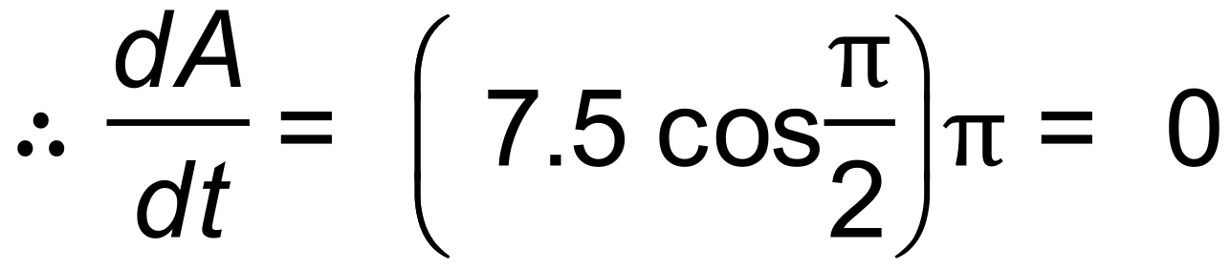
(c) Area has reached a maximum value. [5]

16. (a) 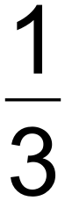
(b) 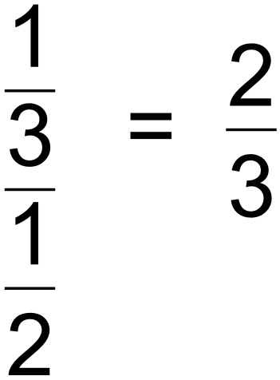
(c) 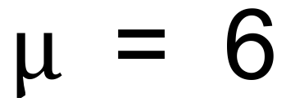 and Var (X) = 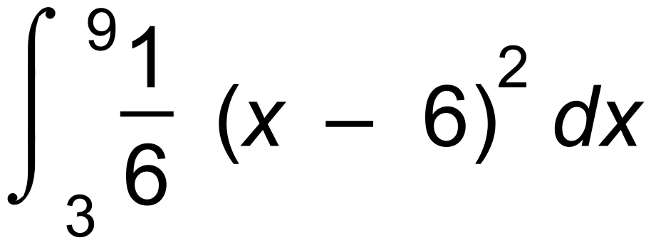 = 3
s(x) = 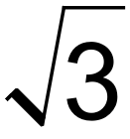 or 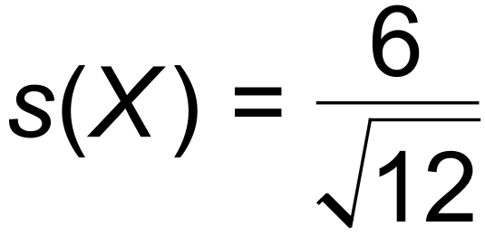 by formula
(d)
s(y) = 2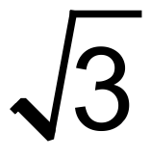 [7]

17. (a) P(390 < X < 410) = 0.15852
(b) P(X < 400 + k) = 0.96
∴ 400 + k = 487.534
∴ k = 87.534
(c) m = 810 s = 100 [6]

18. (a) 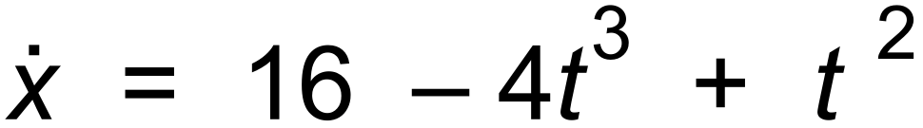
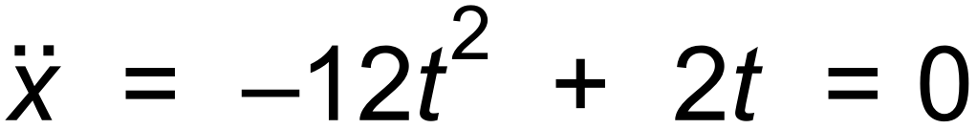
∴ t = 0 or 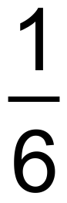
(b) 16 – 4t³ + t² = 0
t = 1.68
(c) –12t² + 2t is a maximum when –24t + 2 = 0
ie when t = 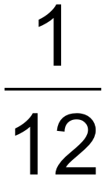
x = 5.33
(d) 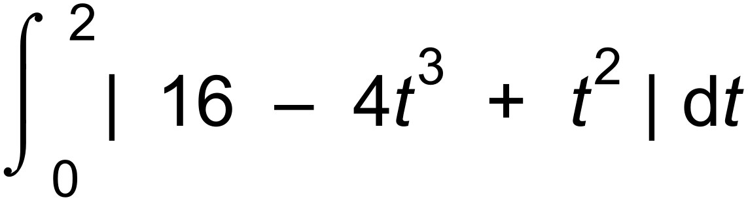 = 22.323 m [8]

19. (a) Normal curve
(b) mean = 21
standard deviation = 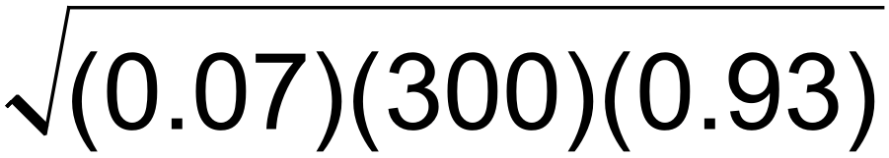 = 4.4193
(c) 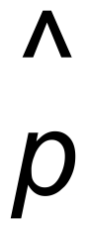 = 0.07
standard deviation = 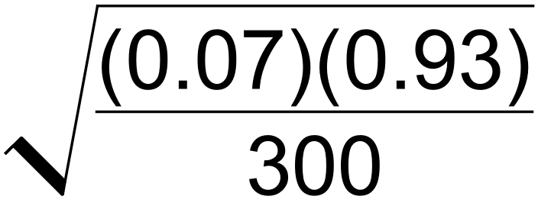 = 0.0147
(d) This is a proportion of 0.15
Z = 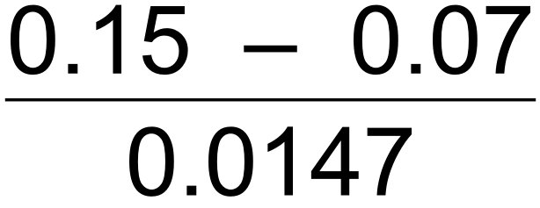 = 5.44
5.44 standard deviations above the mean is very unlikely.
The testing method may need reviewing. [8]

20. (a) Binomial ( 100, 0.02)
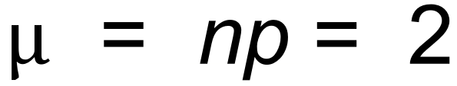
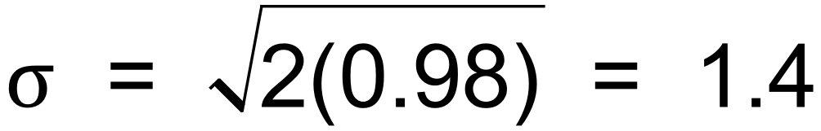
(b) = 0.0508
(c) n = 2000, p = 0.02, X = 40
90% interval is 0.0149 to 0.0251 from CAS
(d) P(X = 2) = ³C₂ (0.9)²(0.1) = 0.243 or from CAS
(e) 0.0149 x 2000  30
0.0251 x 2000  50
(f) Interval is from 30 to 50.
Sample 2 is outside. ( 57 > 50 )
Sample 3 is outside. ( 28 < 30 ) [13]

